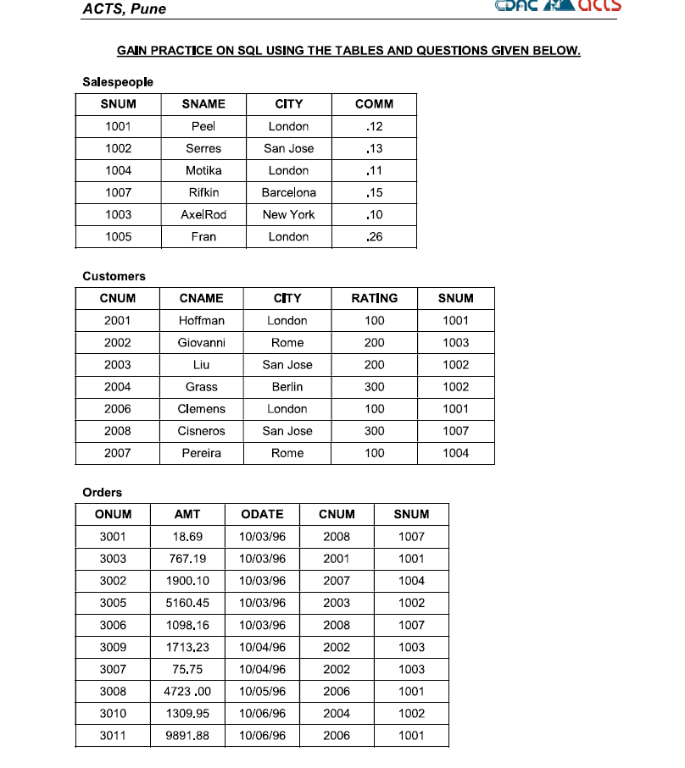

--6. Find which salespeople currently have orders in the Orders table

mysql> select s.snum, s.sname from Salespeople s right join Orders o on o.snum = s.snum group by o.snum;

+------+---------+

| snum | sname |

+------+---------+

| 1001 | Peel |

| 1002 | Serres |

| 1003 | AxelRod |

| 1004 | Motika |

| 1007 | Rifkin |

+------+---------+

-- 7. List names of all customers matched with the salespeople serving them

mysql> select c.cnum, c.cname,c.snum,s.sname from Customers c left join Salespeople s on c.snum = s.snum;

+------+----------+------+---------+

| cnum | cname | snum | sname |

+------+----------+------+---------+

| 2001 | Hoffman | 1001 | Peel |

| 2002 | Giovanni | 1003 | AxelRod |

| 2003 | Liu | 1002 | Serres |

| 2004 | Grass | 1002 | Serres |

| 2006 | Clemens | 1001 | Peel |

| 2007 | Pereira | 1004 | Motika |

| 2008 | Cisneros | 1007 | Rifkin |

+------+----------+------+---------+

-- 8. Find the names and numbers of all salespeople who had more than one customer

mysql> select c.snum, s.sname from Customers c left join Salespeople s on c.snum = s.snum group by c.snum having count(c.snum) > 1;

+------+--------+

| snum | sname |

+------+--------+

| 1001 | Peel |

| 1002 | Serres |

+------+--------+

-- 9. Count the orders of each of the salespeople and output the results in descending order

mysql> select snum, Count(snum)as total from Orders group by snum having count(snum) > 1 order by total desc;

+------+-------+

| snum | total |

+------+-------+

| 1001 | 3 |

| 1002 | 2 |

| 1003 | 2 |

| 1007 | 2 |

+------+-------+

--10 Count the orders of each of the salespeople and output the results in descending order

-- 11. Match salespeople to customers according to the city they lived in

-- 12. List all the orders of salesperson Motika from the Orders table

-- 13. Find all customers with orders on October 3

-- 14. Find all pairs of customers having the same rating

-- 15 List the largest orders for October 3, for each salesperson

-- 16. Write a query that produces all customers serviced by salespeople with a commission above 12%. Output the customer's name and the salesperson's rate of commission.